**Document Analysis**

**Author: William Chanmugam**

**Goals**

Include any observation notes you took as you studied the as-is system. This informal document will indicate current practices and possible stumbling block that may be useful as requirements for the to-be system you will be creating.

**Organizational Chart**

Managers

|  |  |
| --- | --- |
| Tanner Yatsko (Project Manager, Database Developer) | Jas Singh (Product Manager, Presenter/Marketer, Business Analyst) |



Developers

|  |  |  |  |
| --- | --- | --- | --- |
| Niels Verhoeven (Full Stack) | Zach Jaquet (Front End) | Paul Lyon (UI, Front-End ) | William Chanmugam  (UI) |

Business Analysts

|  |  |  |  |
| --- | --- | --- | --- |
| Ben Wang | Densu Kurian | William Chanmugam | Jas Singh |

**History that led to the project**

Deciding what major to take was previously something that was decided by the student with help from an academic advisor. Most of the time incoming freshmen are told to pick a major with limited information about what that studying that major will be like. The outcome of this current system is that many students have trouble choosing their major and start their college career as undecided or in a major they do not like. The unfortunate outcome of this is that many students end up wasting time and money studying a major they will ultimately switch out of. UMBC advising already has a couple options. One being the Focus2 online self-assessment tools that provide users with personalized career exploitation and planning services that are coupled with an in person advising appointment. Another service called Traitify shows a series of images requiring the user to answer “me” or “not me” to, then creates a list a careers and majors that might be helpful. Our team believes we can create a better system that will help students choose a major without the need for an in person advising interview saving students valuable time.

**As – Is Documents**

<https://careers.umbc.edu/students/discover/self/>

This page provides and links and descriptions for the following resources.

**Focus2**

**“**FOCUS2: Career and Education Planning Online Assessment

This online self-assessment tool provides you with personalized career exploration and planning services. Based on your interests, your personality, your talents and your values, FOCUS2 will provide a customized report listing careers that match these areas.

Take the FOCUS2 assessment, then, schedule a 60-minute FOCUS2 appointment with a career advisor to discuss your results.”

Screenshots:

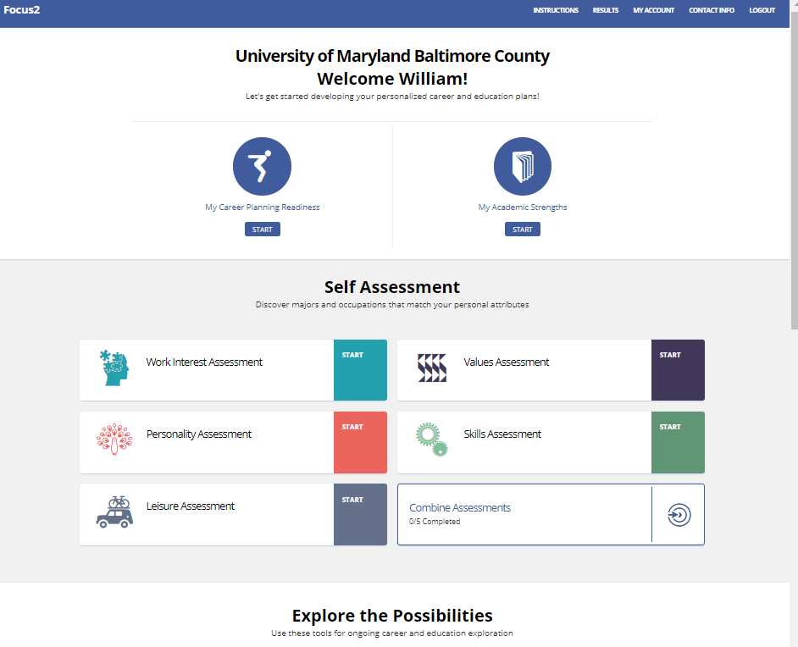

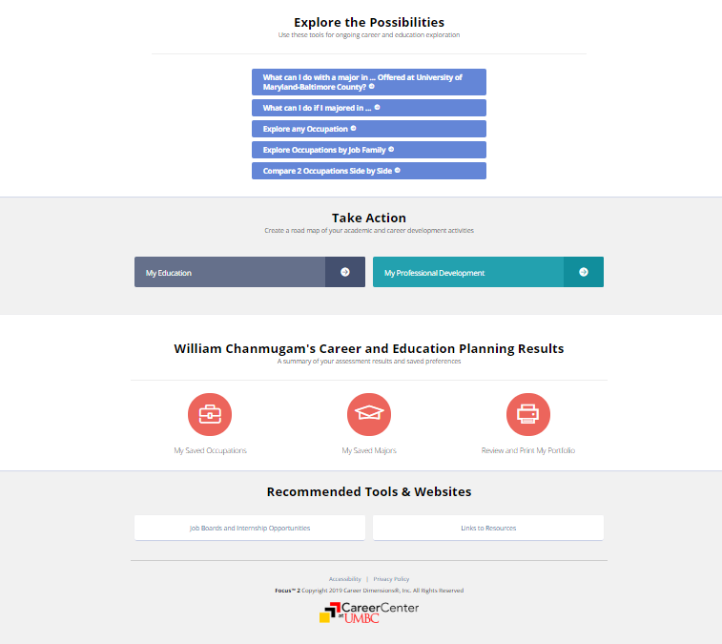

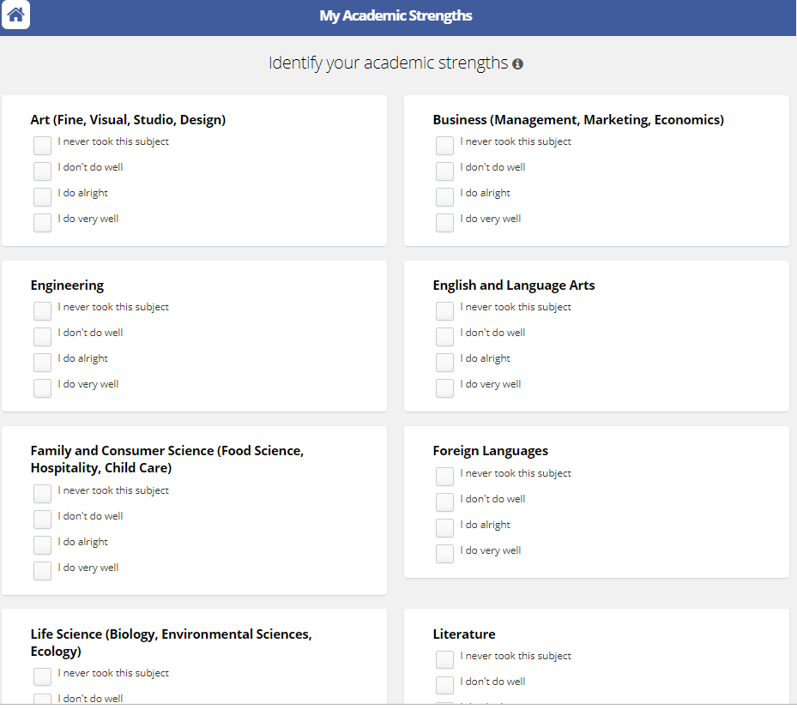

This source contains up to date information and contains other surveys not shown that include a work interests, personality, skills, values, and leisure assessment. Overall this web tool is easy to use and contains tools that go beyond the scope of our current project because it puts a large focus on career planning and allows students to keep track of the academic progress.

**Traitify**

“Get to know yourself with Traitify’s fun visual personality assessment. Simply click “Me” or “Not Me” on a series of images, and in a matter of minutes get recommendations on career paths based on your personality and preference data.

Our Career Specialists can also help you interpret your results, begin exploring your pattern of strengths and clarify your career path. Schedule a 60 minute appointment with a Career Specialist to talk further.”

Screenshots:

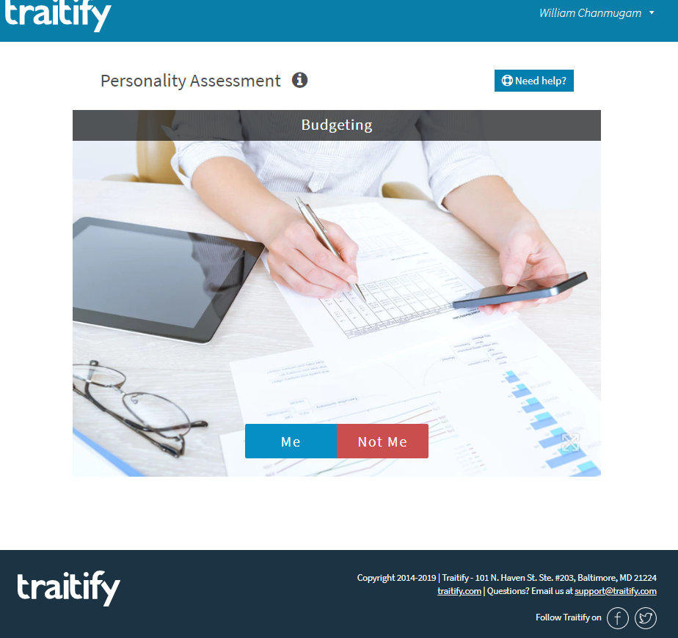

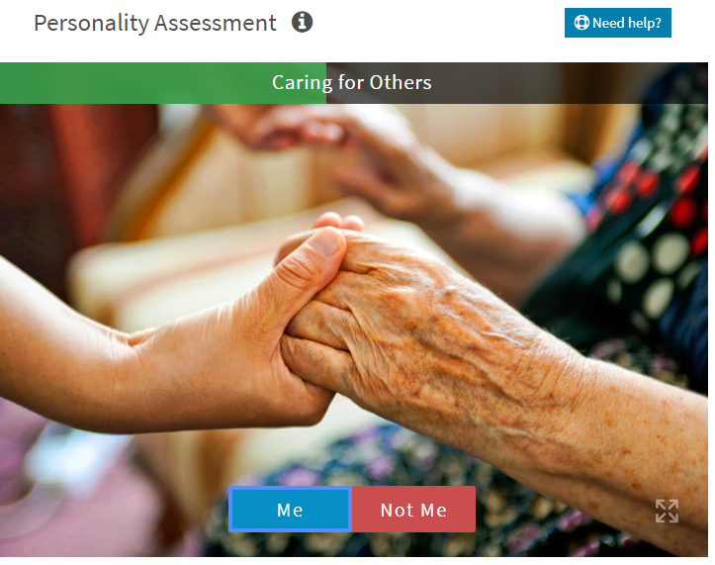

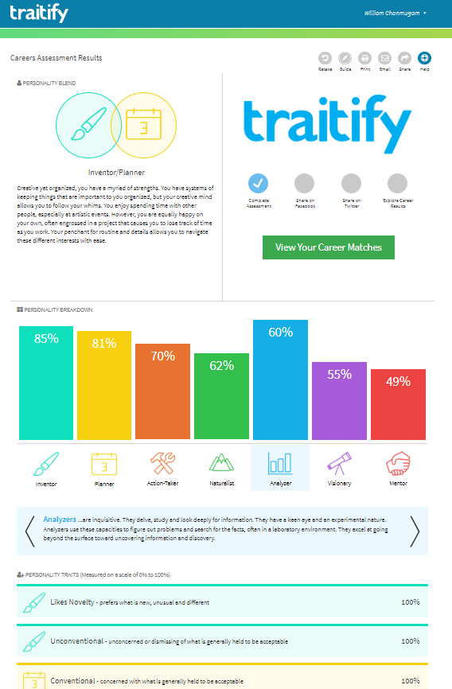 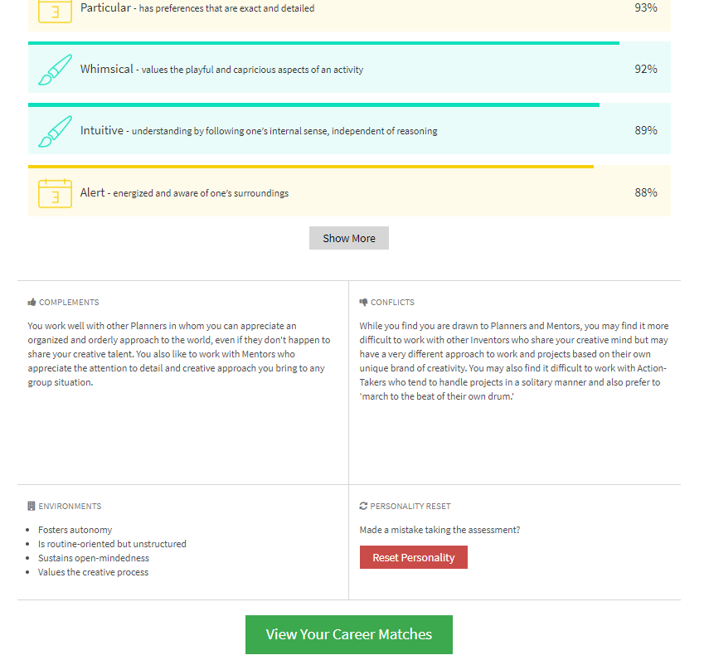

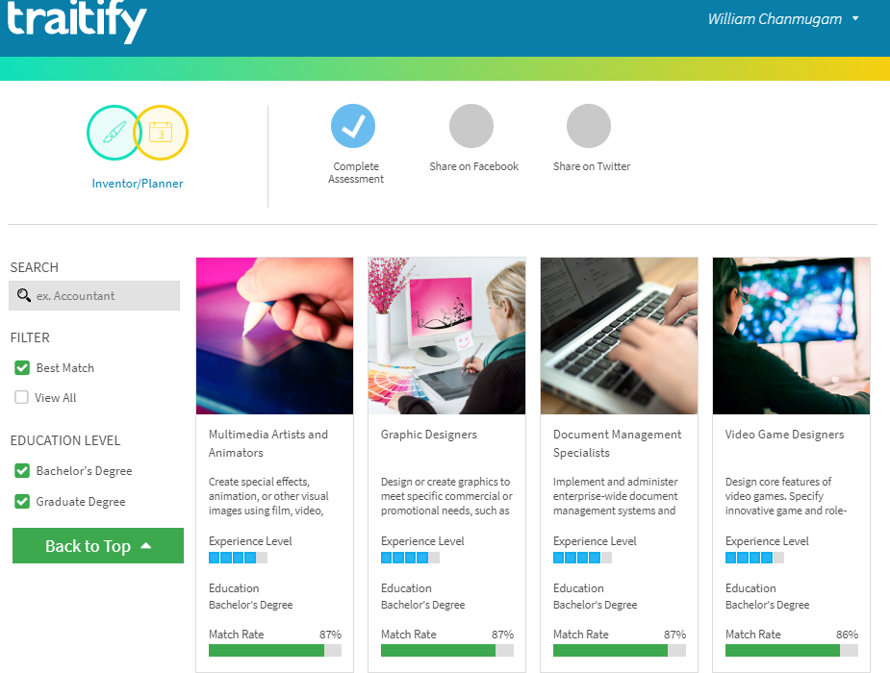

This online tool is simple, fast and easy to use. The tool consists uses a picture of concept and asks the user to choose “me” or “not me”. After you finish the survey the site provides a detailed list of your varying personality traits along with a description of those personality traits. After showing you all your personality traits, it generates a list of different career matches that would well with your personality type. This test differs from our project in that it focusses more on personality type and is more directed at choosing a career instead of choosing a given major. This tool can useful for our project and is a good example of an easy to use program.

**Flowchart of As-Is Option**

